# STOCKS TRADING

**A Project Report**

***Submitted by***

## DHRUV GUPTA

## RUSHABH SHAH

## SOHAM SHAH

***Under the Guidance of***

## PROF. KAMAL MISTRY

***in partial fulfillment for the award of the degree of***

## BTECH

**COMPUTER ENGINEERING**

At



**MUKESH PATEL SCHOOL OF TECHNOLOGY AND MANAGEMENT**

**APRIL 2021**

## CERTIFICATE

This is to certify that the project entitled “STOCK TRADING” is the bonafide work carried out by DHRUV GUPTA, RUSHABH SHAH, SOHAM SHAH of BTECH/MBA Tech, MPSTME (NMIMS), Mumbai, during the IV semester of the academic year 2021, in partial fulfillment of the requirements for the Course Database Management System.

___________________

Prof. Kamal Mistry

Internal Mentor

_______________________ ________________________

Examiner 1 Examiner 2

## DECLARATION

WE,DHRUV GUPTA, RUSHABH SHAH, SOHAM SHAH , Roll No.B019, B049, B051 BTech (Computer Engineering), IV semester understand that plagiarism is defined as anyone or combination of the following:

1. Un-credited verbatim copying of individual sentences, paragraphs or illustration (such as graphs, diagrams, etc.) from any source, published or unpublished, including the internet.
2. Un-credited improper paraphrasing of pages paragraphs (changing a few words phrases, or rearranging the original sentence order)
3. Credited verbatim copying of a major portion of a paper (or thesis chapter) without clear delineation of who did wrote what. ( Source: IEEE, The institute, Dec. 2004)
4. I have made sure that all the ideas, expressions, graphs, diagrams, etc., that are not a result of my work, are properly credited. Long phrases or sentences that had to be used verbatim from published literature have been clearly identified using quotation marks.
5. 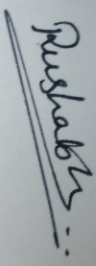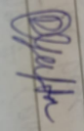I affirm that no portion of my work can be considered as plagiarism and I take full responsibility if such a complaint occurs. I understand fully well that the guide of the seminar/ project report may not be in a position to check for the possibility of such incidences of plagiarism in this body of work.

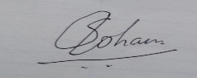

Signature of the Students:

Names: Dhruv Gupta, Rushabh Shah, Soham Shah

Roll Nos. : B019, B049, B051

Place: Mumbai

Date: 31/03/2021

**ACKNOWLEDGEMENT**

We would like to express my special thanks of gratitude to my prof. Kamal Mistry who gave me the golden opportunity to do this wonderful project on the topic Stock Trading, which also helped us in doing a lot of Research and we came to know about so many new things we are really thankful to him.

## Table of contents

Chapter 1: Introduction to the system

1.1 Introduction

1.2 Problem Statement

1.3 Users of the system

Chapter 2: System Design and constraints

2.1 ER Model

2.2 Reduction of ER model to Relational Model

2.3 Schema Diagram

2.4 Constraints

2.5 Normalization techniques applied on relational model

Chapter 3: Implementation

3.1 Hardware and Software details (Front end and Back end details)

3.2 Tools or library used

3.3 Screenshots and description

Chapter 4: Conclusion and Future work

**Synopsis**

**Project title : Database management system for stock trading**

**Introduction:**

 We are developing software for a stock exchange and this software will help in the stock exchange for their database maintenance corresponding to the data given on the basis of requirement.

So, we can say that it helps the management of stock exchange and give exact database management of company stocks. It also helps in maintaining stock data and also display how many stocks are present in the market and also gives the details of these stocks. This software also gives or stores each and every information about trading.

**Project functionality:**

1. Buying of stocks
2. Selling of stocks
3. Watching market stocks
4. Keeping track of stocks owned
5. Maintaining transaction details

**Made by:**

Dhruv Gupta – B019

Rushabh Shah – B049

Soham Shah – B051

**Project Report**

**Introduction to the system :**

We are using Relational Database Management System (RDBMS) for our project. We made our database using Mysql DDL and DML commands. Since stock market gives such huge volumes of capital it is necessary to maintain transaction details of the trading to maintain integrity and trust among traders.

Our model runs a stock trading service. We have built a user-friendly model to buy and sell stocks.

Our system maintains record of each transaction and keep track of user and stock details.

Anyone who wishes to trade stocks can use our model to buy, sell and manage stocks.

**System Design and constraints**

**ER Model:**

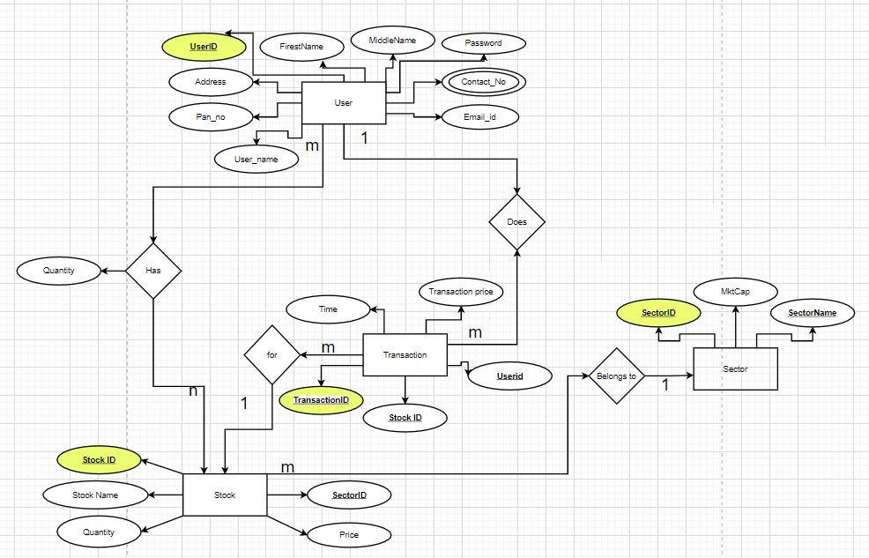

**Reduction of ER model to Relational Model**

Users:(user_id, user_name, contact_no1 ,contact_no2 ,address ,password ,pan_no ,email_id );

Stocks:(stock_id, sector_id, stock_name, pps );

Sector(sector_id, sector_name, mkt_cap);

Transactions:( trans_id, tran_time, trans_price, stock_id, user_id, type, trans_qty );

user_has:(user_id, stock_id, quantity numeric(10));

**Schema Diagram:**

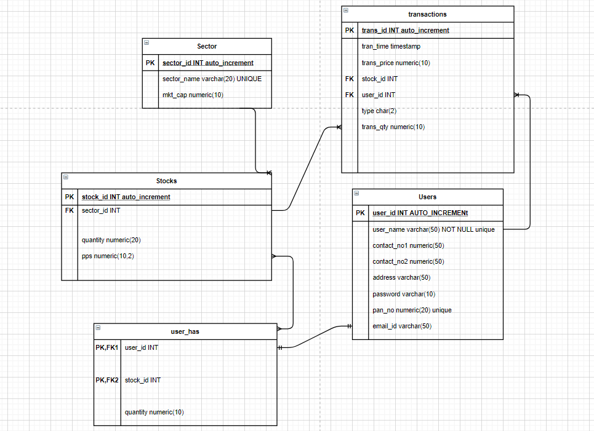

**Constraints:**

TABLE Users:

user_id - PRIMARY KEY, auto increment

user_name -NOT NULL unique

pan_no -unique

TABLE Stocks:

stock_id – auto increment, PRIMARY KEY

sector_id – foreign key,

stock_name - NOT NULL,

TABLE Sector:

sector_id – auto increment , PRIMARY KEY

sector_name - UNIQUE

TABLE transactions:

trans_id – auto increment , primary key

stock_id – Foreign key

user_id - Foreign key

TABLE User_has:

user_id – Primary key, Foreign key

stock_id - Primary key, Foreign key

**Normalization techniques applied on relational model**

We had created isa relation of user to buyer and seller which was then connected to transaction table it was creating redundant entries in the table which was not required so we dropped buyer and seller tables.

In the user table we have 1 multivalued attribute so it was not following the 1NF so we separate the attributes into 2 i.e. contact of user was split into contact 1 and contact 2.

In transaction table we had had attributes buyerid and sellerid as composite primary keys but it was not following 2NF due to partial dependency on either 1 so we replaced them into userid to avoid partial dependency

We had sector id and sector name as attributes in the stocks table which was creating transitivity so we created a new table sector with sector id as primary key and referenced it in stocks to follow 3NF.

After normalizing the er diagram to 3NF we found that it was satisfying the conditions for BCNF and so our model was normalized.

**Implementation**

**Hardware and Software details :**

* Mysql workbench
* Pycharm community server
* Ms word (report)

**Tools or library used:**

* Tkinter
* Mysql.connector
* Mysql
* Python
* Draw.io
* Tkinter.ttk

**Screenshots and description:**

1.)select user_name,password from users where user_name = %s and password = %s

This query is used in login function to verify the login credentials of the user

2) insert into users(user_name,password,contact_no1,contact_no2,address,pan_no,email_id) values(\"{}\",\"{}\",\"{}\",\"{}\",\"{}\",\"{}\",\"{}\")

This query is used to register user details into the database system

Users table:

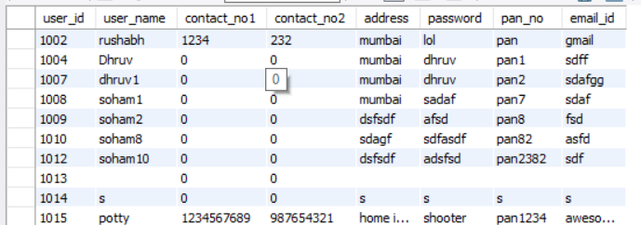

3) select stock_name from Stocks

This query is used to display available stocks in the market to the buyer

4) select pps,quantity,stock_id from stocks where stock_name = \"{}\"

This query displays the details of the stock selected by the buyer

5) select user_id from users where user_name = \"{}\"

This query fetches the user id to display buyer or seller details in transaction

6) select stock_id from user_has where user_id = {}

This query will select the stock id of the stocks owned by the user

7) select stock_name from stocks where stock_id = {}

This query will select the stock’s name using stock id

8) select pps,stock_id from Stocks where stock_name = \"{}\"

It will display the details of the stock owned by the user

9) select quantity from user_has where stock_id = (select stock_id from stocks where stock_name = \"{}\") and user_id = {}

This query will retrieve the quantity of stock owned by user

10) select s.stock_id,s.stock_name,s.pps,uh.quantity from stocks s Inner join user_has uh on uh.stock_id = s.stock_id where (s.stock_id, uh.user_id) in (select stock_id,user_id from user_has where user_id = {})

This query will collect the data of stock owned by user and its price quantity etc.

11) 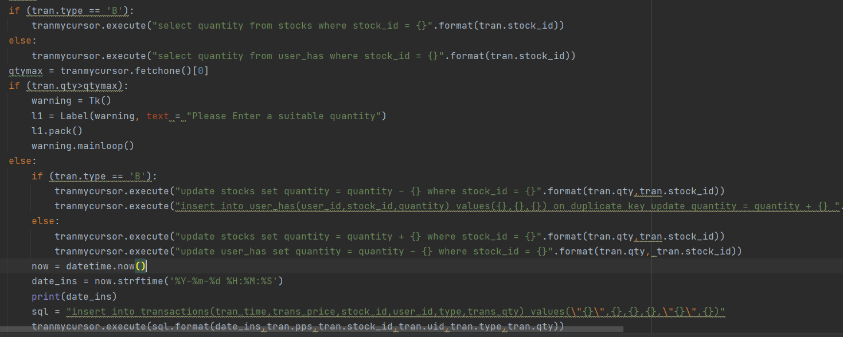

This queries are used to fetch stock details in the market and owned by the user

Also to update and insert the transaction details made by the user in buying and selling the stocks

Transaction table:

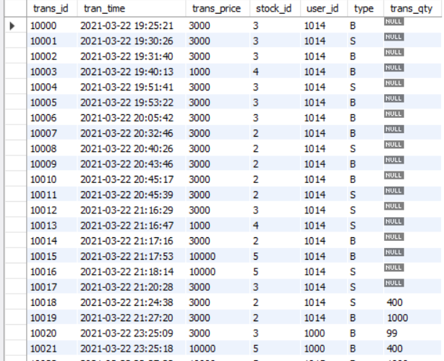

Stocks Table:

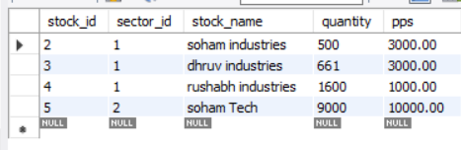

Sector Table:

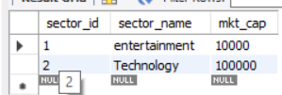

User has table:

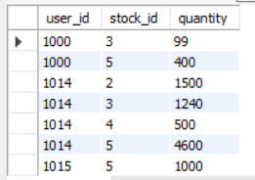

Login Screen:

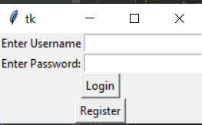

Registration :

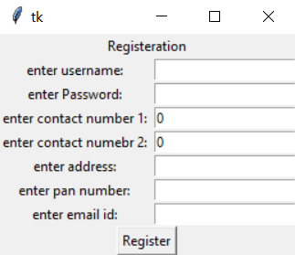

Dashboard:

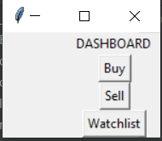

Buy:

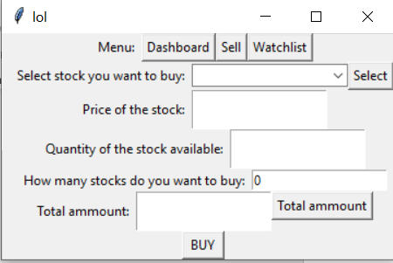

Sell:

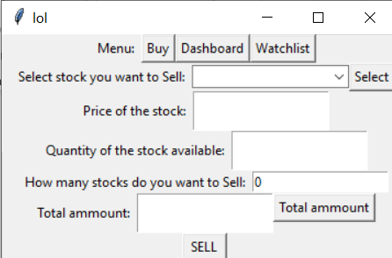

Watchlist:

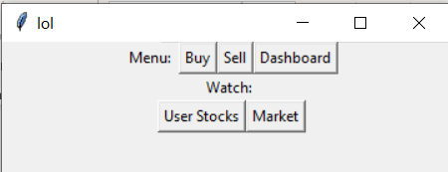

User Stocks:

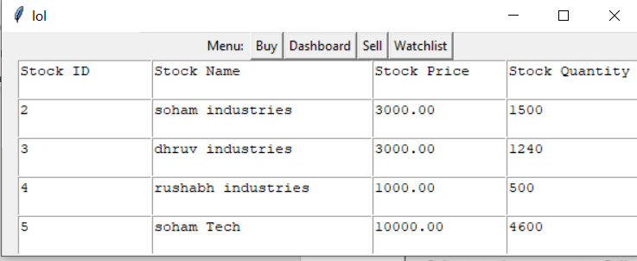

Market:

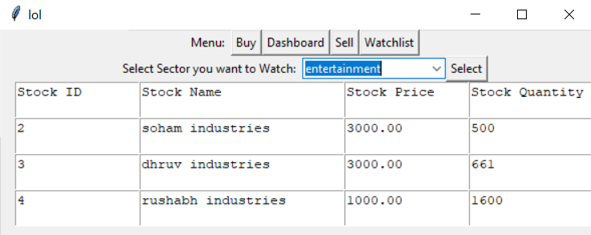

**Conclusion and Future work**

* We can take dynamic entries for the stocks i.e. values of stocks varying with time
* We can add features like favorite stocks to watch
* We can add forex trading, Cryptocurrency trading, commodities(gold , silver) trading
* We can build a better frontend GUI using enhanced designing
* We can connect to banks for real currency trading
* Also buying and selling of stocks simultaneously
* We can add feature to connect with aadhar card

We conclude that our model works successfully and we have applied and understood all the concepts of database management system efficiently